Myocardial Tissue Engineering

Primary authors

Erika Johannesen, Kathy Buehmann, Elizabeth O'Donnell, Christopher Wilson

Motivation
Heart disease has been the leading cause of death in developed countries for most of the last century, is the leading cause of death in every state except Alaska, and accounts for 30% of all deaths in the United States. The most common form of heart disease is coronary artery disease is a wide definition for any disease that develops due to the constricting of arteries supplying the heart. The most common forms of CAD result in heart attacks, heart failure, or angina (severe chest pain). With 1,200,000 incidents each year, CAD is one of the most common ailments in the United States. Furthermore, it is also one of the most deadly classes of diseases. Approximately 38% of those who experience a form of CAD die because of it. CADs are generally caused by high cholesterol, high blood pressure, obesity, and unhealthy habits like smoking and lack of exercise, all of which contribute to the narrowing of arteries. If Coronary artery diseases progress far enough, some of the most serious effects like myocardial infarction and heart failure are seen. Myocardial infarctions (heart attacks) occur when a portion of the heart is suddenly deprived of blood and oxygen because the artery supplying that section has become blocked. Without blood flow, the heart muscle quickly dies resulting in scar tissue formation at the site. If the patient survives the initial heart attack, the scar tissue formed causes further problems for the patient because it does not contract with the rest of the heart, severely impeding the heart's ability. Without treatment, this leads to congestive heart failure. Another common result of CAD is angina, a painful sensation of chest tightening arising from a lack of oxygen to the heart. Someone experiencing angina will experience a severe chest pain because the heart has to work harder to pump blood through the narrowed arteries.
With CADs being the number one cause of death in the United States, it is crucial that we find prevention or treatment methods. Current treatments of Congestive heart diseases assist the failing heart rather than regernerate it. Therefore, all factors of CAD would benefit from significantly improved treatments with the development of successful cardiac tissue replacements. Because of this, cardiac research has begun to investigate the possibility of engineering myocardial tissue replacements as a response to the increasing prevalence of this disease. While this technology is still young, significant advances are being made everyday.

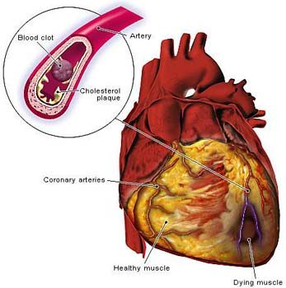

Depiction of myocardial infarction

Previous work
Tissue engineering is a fairly new concept in medicine, where the aim is to repair or replace damaged organs or tissues by delivering functional cells, scaffolds, growth promoting factors, and electrical and physiological signals to areas that need it. This technique is already well established for replacing skin, cartilage, bone, and bladder. Myocardial tissue engineering addresses repairing the heart muscle, or myocardium, after loss of blood flow typically resulting from myocardial infarction. The majority of the myocardium is found in the bottom portion of the heart, surrounding the ventricles.

Traditional Cardiology

Because of such a high mortality rate, significant medical attention has been spent on cardiology. That being said, the most common treatments for heart disease are still lifestyle changes. Due to medical costs, lifestyle changes will likely remain the primary treatment for heart disease even after the most promising of today’s conceivable advances are made. Recommended lifestyle changes include improving diet, increasing exercise, and refraining from behaviors such as smoking. The best advances in traditional cardiology are those pertaining to arrhythmias, heart failure, and myocardial infarctions, all of which can be caused by coronary artery disease. Arrhythmia is a general term for any condition where the heart exhibits abnormal electrical activity. While most arrhythmias may have no significant consequence on a person’s overall wellness, their presence indicates a risk of sudden arrhythmic death, where the heart suddenly loses its synchronicity and its ability to pump blood. Also, certain types of arrhythmias, such as atrial fibrillation, can generate clots that can dislodge and block small vessels in the heart, lungs, and brain. The first major advance in treating arrhythmias, the EKG, which was pioneered by Willem Einthoven in the 1890s is still the most common tools for diagnosing heart problems. The EKG measures electrical activity in the heart by measuring voltage differences on selected points on the skin’s surface. Normal healthy hearts follow a very predictable pattern of electrical activity, and actual values for timing and intensity of the various electrical waves the heart generates are well documented. Deviation from this pattern indicates damage to the hearts pacemaking conductive tissues which generally occurs in conjunction with damage to contractile tissues. Today, with the help of complex electronic instrumentation, the heart can actually be mapped by its electrical activity with techniques such as endoepicardial atrial mapping and antegrade ventricular mapping. Currently, arrhythmias are treated surgically, with various drug therapies, and with pacemakers. Sometimes loci along the heart generate their own electrical signals without following the normal chain of events stimulated by the sinoatrial node. With the information gathered by mapping the heart these loci can be removed surgically. More recently, a procedure called endocardial fulguration has been used to achieve the same goal by destroying a small amount of myocardium with an electric shock delivered through an endocavitary catheter. For patients where an arrhythmia seems unrelated to an underlying structural heart disease, drug therapies are also used. Drugs such as quinidine, digoxin(or digitalis), and various beta-blockers are given in various cocktails depending on the exact arrhythmia to stop the arrhythmia and prevent it from degenerating into a more serious dysrhythmia. Patients whose arrhythmias cause severe bradycardia (slow heart rate) or tachycardia (fast heart rate) are generally given pacemakers. The pacemaker delivers electronic impulses to the heart, regulating its contractions. Modern pacemakers also read the hearts electrical activity to detect and override tachycardic arrhythmias. Tissue engineering shows promise in that it can theoretically replace failing portions of the heart that cause arrhythmias. Coronary artery disease is the leading cause of death among heart conditions and killed over 7 million people worldwide in 2007. Coronary artery disease results from loss of elasticity and build-up of fatty deposits in the coronary arteries. Narrowing of the coronary arteries increases the risk of myocardial infarction and can lead to congestive heart failure. Current treatments for these conditions are primarily surgical and pharmacological in nature, respectively. Patients that have been assessed to have a high risk of myocardial infarction are also given pharmacological treatments. The four main goals of drug therapies in patients with CAD are vasodilation, decreasing myocardial oxygen demand, preventing clotting, and lowering cholesterol. Vasodilators are drugs that dilate blood vessels, increasing blood flow, and are given to patients with angina. Nitroglycerin is particularly good at targeting the coronary arteries. Beta-blockers and calcium channel blockers decrease the hearts contractibility and excitability to lower the oxygen demand that the heart places on itself. Heart tissue under the influence of these drugs will not die as quickly in the event of an infarction. In patients where the risk of heart failure outweighs the risk of myocardial infarction, drugs like digoxin, which increase the pumping strength of the heart, are preferred over drugs that decrease myocardial oxygen demand. Antiplatelet drugs and anticoagulants are given to patients with high risk to decrease the likelihood that a blood clot forms in a coronary artery. Examples of these are aspirin and heparin, respectively. People taking these drugs have a much higher risk of bleeding disorders. Drugs to help lower cholesterol are given to almost everybody with “high” cholesterol. Once coronary artery disease leads to a myocardial infarction, emergency services will use a class of drugs called fibrinolytics, which chemically break down the fibrin that holds blood clots together. Provided the patient makes it to the hospital, surgical procedures are taken to reopen blood flow to the infarct zone. The first procedure developed for this was coronary artery bypass graft surgery. In this procedure, a vein from part of the body is grafted to the heart to circumvent blood around the site where there is blockage. Compared to the swift mortality a myocardial infarction can cause, this procedure is slow and requires open heart surgery. Today’s most common procedure is angioplasty followed by the placement of a stent. Angioplasty is a simple but innovative procedure where a balloon is run through the arteries to the site of blockage, is inflated, then removed and replaced by a stent to hold the blood vessel open. This procedure is fast and much more effective at clearing multiple blockage sites. However, in any case of a myocardial infarction a portion of the heart muscle is left dead. Myocardial tissue engineering could theoretically replace necrotic heart tissue.
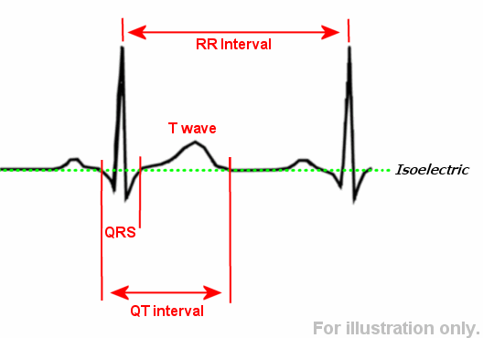
Heart transplants: The LVAD and AbioCor

Most cases of heart disease that result in death pass through a phase known as end-stage heart failure. The main exceptions to this are myocardial infarctions that cause immediate death. End-stage heart failure is defined as a heart condition that doesn't respond to medical or surgical repairs. The first legitimate medical treatment for end-stage heart failure was the heart transplant. The first successful heart transplant was completed in South Africa in 1967. Today, heart transplants are relatively common and successful procedures and as many as 50 percent of all recipients living longer than 10 years after the procedure. Still, this procedure is very risky, only working with very well selected candidates and donor hearts. Severe immunological rejection of donor organs requires lots of immunosuppressing drug treatments that often end in infection and even cancer. However, the biggest downside of heart transplants is the insufficient supply of donor hearts. End-stage heart failure coupled with the meager supply of donor hearts first prompted searching for mechanical heart replacement and assist devices. The first widely used total artificial heart, the Jarvik-7, was first used in 1982. The patient lived for 112 days following implantation. This device was rudimentary by today’s standards, with drawbacks ranging from noisiness to wires running through the skin increasing vulnerability to infection. The current standard for mechanical heart replacements is the ABioCor artificial heart, which was first successfully implanted in 2001. The ABioCor improved upon its predecessors by being completely self-contained. While the Jarvik-7 had to be constantly connected to a pneumatic pumping machine, the ABioCor contains its own motor. It is also powered without wires using technology similar to that of a power transformer. Perhaps the best advancement in this device is the polymer Angioflex which addressed a big problem of blood cell damage and embolisms. Some patients that have received the ABioCor have been able to leave the hospital following implantation. The ABioCor was approved by the FDA in 2006 as a humanitarian device, and its price and strict regulation prevent it from being widely used at this time. The device also has a limited lifetime of around 5 years and at that point begins to suffer from mechanical failure. The issue of mechanical failure in total heart replacements has been addressed by heart assist devices. Heart assist devices can be implanted to assist either the right or left ventricle in a much broader group of patients than total heart replacements. They are also much less costly and require a less risky procedure. HADs are placed on the abdomen and continuously pump blood from the bottom of the ventricle into the Aorta (HADs are almost always assist the left ventricle). HADs approximately double the survival rates of end-stage heart failure patients. They have also allowed patients to survive long enough to receive heart transplants. Because the heart still contributes to the overall pump, pulsatile flow is still present. Both pulsatile and nonpulsatile HADs are used clinically. Currently the most common pulstatile LVAD is the HeartMate, and the most common nonpulsatile LVAD is the DeBakey-Noon axial flow pump. Pulsatile pumps naturally create better pulsatile flow through the aorta, but are large and can have mechanical problems. Nonpulsatile pumps on the other hand, generate less pulsatile blood flow, but are compact and mechanically simple. That being said, according to a publication submitted by researchers at the University of Marylandmedical center, “Similarly ill congestive heart failure patients benefited equally well from either a nonpulsatile or a pulsatile LVAD.” Several other papers on the same subject have been written and they all draw the similar conclusion that nonpulsatile devices are more practical for long term use.

Engineering Cardiac Tissue
A significant amount of research attention has been given to what cell types to use when trying to engineer cardiac tissue. Natural cardiac tissue is very complex, consisting numerically of approximately 30 percent cardiomyocytes, the actual contractile cells, 60 percent fibroblasts, which tether the cardiomyocytes to an extensice extracellular network of collagen and other structural proteins. The remainder of cells are primarily endothelial cells found in the vasculature. Growing such a complicated tissue becomes even more challenging since cardiomyocytes are terminally differentiated cells and do not normally divide. The ideal cell source for this goal would be easy to harvest, easy to grow, nonimmunogenic, and resistant to ischemia, and most importantly be able to differentiate into functional cardiomyocytes. Any sort of cardiac would also need to vascularize quickly following implantation. Currently the closest current treatment to tissue engineering is cardiac cell therapy with skeletal muscle progenitors and bone marrow mononuclear cells to treat myocardial infarction patients shortly after the event. This does not show any usefulness in chronically infarcted myocardium. Both of these cell sources have drawbacks for application in tissue engineering. Skeletal muscle progenitors can't differentiate into cardiomyocytes and can't synchronize with the rest of the hearts electrical activity. Bone marrow cells have a tendency to calcify. Other cell types that have been considered include embryonic stem cells, mesenchymal stem cells, hematopoietic stem cells, and cardiac progenitors. Except for hematopoietic stem cells, these are very hard to harvest. Hematopoietic stem cells have not been proven to undergo cardiac myogenesis. Embryonic stem cells have the advantage of being highly expandable, but controlling their differentiation is not yet understood and they pose the risk of becoming cancerous. The next step in engineering a functioning cardiac graft is selecting the appropriate biomaterial. Alginate-gelatin materials impregnated with drugs that promote angiogenesis can actually be placed in-situ on an area to be repaired and will vascularize before cells are even introduced. More on biomaterials will be discussed in future techniques. The third major project is finding what drugs should be delivered to the cardiac graft. The goals of these drugs would be to stimulate cell division, myogenesis, angiogenesis, and to keep the cells from becoming apoptotic. Recent research has allowed us to isolate vascular epithelial growth factors, which stimulates angiogenesis. Erythropoietin is another hormone that promotes angiogenesis. There are also a whole host of growth factors that could theoretically serve to promote cell division and myogenesis.

Future Strategies
Tissue Engineering from Natural Sources
Engineered myocardial tissue consists of two parts: cells and an extracellular (EC) matrix. Cells can be obtained from a variety of sources, including from the patient herself (autologous), from a donor (allogenous), from an animal (xenogenic), or as stem cells. These cells must be implanted onto a scaffold, a three-dimensional structure that serves such purposes as to protect the implanted cells from immune attack, promote cell growth, offer a site for cell attachment, encourage the growth of blood vessels into the new cells, and in general provide a bridge between the environment of a laboratory and the biological and mechanical conditions found within the body before dissolving harmlessly into the blood stream. Collagen, a fibrous protein naturally found in the body's extracellular matrix, is one of the most popular natural scaffolds used in myocardial tissue engineering. It tends to promote cell attachment and vascularization while increasing mechanical support; however, its considerable immunogenicity remains problematic. The use of collagen in combination with various types of cells yields varying benefits and drawbacks, on overview of which can be found below. Some of the biggest challenges still faced with natural myocardial tissue engineering include inducing cell contractibility, increasing cell proliferation, and effectively delivering cells to the damaged region of the heart.

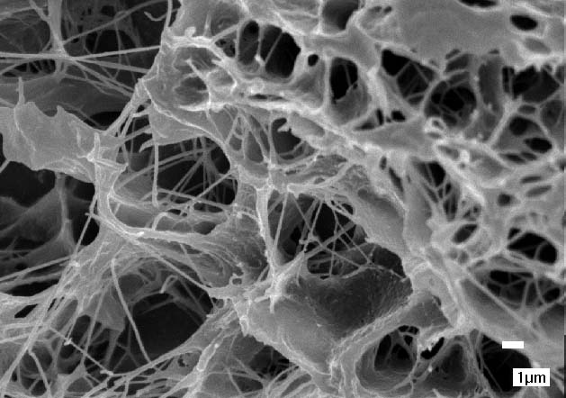

Collagen scaffold

Tissue Engineering from Natural and Artificial Sources
Beyond singularly natural sources, there is current research into combining natural and synthetic sources for repairing myocardial tissue. Combining the two ensures the mechanical strength and provides a solid foundatoin upon which cell growth can occur while maintaining biocompatibility through the natural component. Typically, the combination is done utilizing either bioreactors or electrospinning. Bioreactors mimic in vivo conditions while encouraging growth of cells associated with the artificial matrices. The cell-polymer construct is immersed in growth-promoting medium and is encouraged to develop more than just a few cell layers. Other benefits include an increase in the supply of oxygen and other gases that allow the biomaterial to more accurately mimic real tissue upon implantation. Alternatively, electrospinning meshes collagen fibrils with artificial biomaterials to create scaffolds with predetermined fiber diameters. The polymer-collagen mixture is forced from a pipette by electrically charging it and distributing it onto a screen where it can dry, leaving a polymer-collagen fiber. Many of the natural cell sources are associated with artificial polymer through either of these protocols.

A Summary of Tissue Engineering Techniques
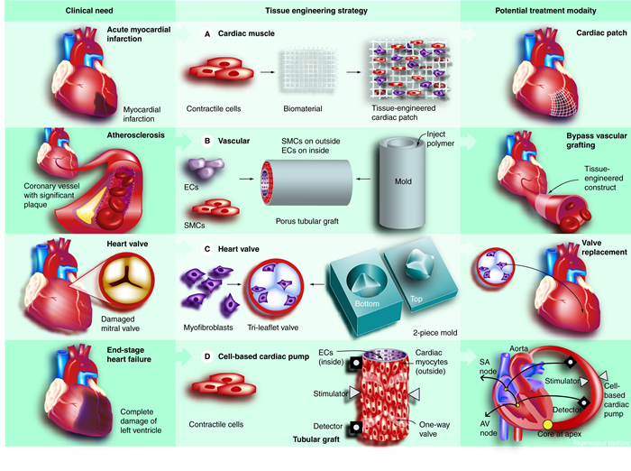

Tissue Engineering from Artificial Sources
Researchers have not only been examining
how
to incorporate natural cell sources and synthetic polymers, but have also been trying to eliminate the natural component entirely. A few such polymers have been examined with limited success. Poly (alpha hydroxy acid) aliphatic polyesters have been used for years with wide ranging uses and their utility is being expanded to myocardial engineering. Poly lactic (PLA) and poly glycolic acids (PGA) are the major subunits comprising degradable sutures and when used as a replacement for myocardial tissue it has a few advantages. The degradation rate can be predetermined by altering PLA/PGA ratios, a variety of shapes can be created, and the mechanics of the implant can be directed more effectively. Unfortunately when the poly acids degrade, the acidity of the tissue increases making it more susceptible to inflammation. The degradation also leads to a significant loss of mechanical strength that might still be required. Most importantly, poly acids do not mimic the elasticity and contractability of native myocardial tissue which is a requirement of replacement myocardial tissue. A different synthetic polymer, elastomeric polyurethane, remedies that issue. Elastomeric polyurethane has been shown to demonstrate good cell adhesion and no tissue inflammation which is helpful in tissue engineering success. As the polyurethane degrades, however, diisocyanate is produced as the biproduct which is detrimental to cell health.

Cell Type | Scaffold | Overview | Advantages | Disadvantages | Contributors*
Natural materials
Neonatal cardiomyocytes | Collagen type I matrix and Matrigel | Made in circular moulds under an auxotonic load to provide mechanical strain  Culture supplemented with oxygen and insulin | Contractible  Myocardium formed  Functional and morphological heart properties mimicked  Controllable shape and size  Increased cell attachment | No improvement of left ventricle function  Immunogenic  Poor mechanical properties | Zimmermann et al., 2006
Rat ventricular cells | 3-d gelatin mesh (Gelafoam) | Cells seeded onto mesh | Contractible  Forms junction with heart | No improved cardiac function | Li et al., 2000, 1999
Bone-marrow derived mesenchymal stem cells | Electrospun collagen + glycosaminoglycan (GAG) | Nanofibrous scaffold formed | Cell proliferation  Vascularization  Increased cell attachment | Immunogenic  Poor mechanical properties | Zhong et al., 2005  Xiang et al., 2006  Kofidis et al., 2002
Neonatal rat cardiomyocytes | Electrospun collagen + glycosaminoglycan (GAG) | Nanofibrous scaffold formed | Cell proliferation  Vascularization  Increased graft thickness  Increased cell attachment | Immunogenic  Poor mechanical properties | Zhong et al., 2005  Carrier et al., 1999
Undifferentiated mesenchymal embryonic stem cells | Electrospun collagen + glycosaminoglycan (GAG) + collagen type I matrix | Nanofibrous scaffold formed  Intramural pouch surgically created | Cell proliferation  Vascularization  Myocardial geometry and wall thickness left unchanged  More gap junction proteins  Increased cell attachment | Immunogenic  Poor mechanical properties | Zhong et al., 2005  Kofidis et al., 2005
Heart cells | Gelafoam | Cyclic mechanic stress applied | Proliferation (due to mechanical stress)  Cell distribution (due to mechanical stress) |  | Akhyari et al., 2002  Liu et al., 1999
Embryonic stem cell-derived cardiomyocytes | Type I collagen + matrigel | Pipetted into circular molds, incubated, then stretched | Good technique for cell seeding  Increased cell attachment | Poor mechanical properties | Guo et al., 2006
Cardiomyocytes | Collagen tissue fleece | Cells seeded onto collagen fleece | Contractible  Homogenous cell distribution  Vascularization  Progenitor mobilization  Mechanical support  Increased cell attachment | Immunogenic | Koofidis et al., 2003
Cardiomyocytes | Collagen tissue fleece + acellular 3D collagen scaffold | Grafted onto rate hearts | Reduced cardiac remodeling  Vascularization  Mechanical support  Increased cell attachment | Immunogenic | Gaballa et al., 2006
Fetal rat cardiac cells | Sodium alginate scaffolds | Scaffolds made by freeze-drying | Vascularization  Encouraged cardiac cell culture  Regeneration and healing potential | Few myofibers embedded in collagen matrix | Leor et al., 2000  Shapiro and Cohen, 1997
Embryonic stem cells | Alginate (negatively-charged natural biomaterial) | Cells seeded onto alginate scaffolds | Vascularization  Mechanical support | No significant myocardium regeneration  Thrombocytic  Inflammation | Leor et al., 2006
Embryonic stem cells | Alginate (negatively-charged natural biomaterial) | Centrifugal force during cell seeding | More cells loaded onto scaffolds (than without centrifugal force)  Higher density cells  More uniform cellular distribution |  | Dar et al., 2002
 | Four-layer urinary-bladder derived EC matrix | Used as cardiac patch | Reduced thrombocytosis and implantation  Mechanical benefit to myocardium | Necrosis  Calcification | Robinson et al., 2005  Kochupura et al., 2005
Natural and synthetic materials
 | Electrospun poly(ester urethane) urea + type I collagen |  | Improved cell adhesion | Unoptimized mechanical properties | Stankus et al., 2004
Neonatal Lewis rat cardiomyocytes | Electrospun, nanofibrous polycaprolactone (PCL) meshes + type I collagen | Mesh made of wire ring, coated with collagen | Enhanced cell adhesion  Wire ring enables cells to beat at natural frequency  Heart topography mimicked |  | Shin et al., 2004
Neonatal heart cells | Polyglycolic acid (PGA) + collagen sponge (Ultrafoam) | Bioreactor cartridges used to seed cells onto composite scaffold | Improved cellularity  Presence of cardiac markers |  | Radisic et al., 2003
Multipotent bone marrow-derived mesenchymal progenitors | Collagen type I and IV + Matrigel | Cells seeded onto matrix, then matrix seeded onto poly(lactic acid) polymer mesh  Transplanted onto infarcted syngenic rat hearts | Minimal inflammation  Retention of fibroblastic shape  Junction of native and implanted myocardium  Cell differentiation  No cardiac arrythmia |  | Krupnick et al., 2002
*Please see H. Jawad et al. for full citations

Tissue Engineering Techniques
Because this technology is so new, there are many different approaches being researched for growing and implanting the tissue. One technique being looked at is layering cardiomyocytes on a polyurethane film. This technique results in the slow build up of the tissue as the cells become attached together. Implantation of cells grown in this manner has, so far, been very successful. Another technique that is being looked into utilizes skin fibroblast cells as opposed to heart cells. This research is using Dermagraft tissue (artificially engineered skin tissue) and implanting it in the heart to stimulate the growth of blood vessels in the tissue damaged by the heart attack. While this technique
does
nothing to regain the function of the tissue lost due to cardiac infarction, it
does
slow the loss of function of the tissue. One of the biggest issues with myocardial tissue engineering that is addressed with the next technique involves engineering tissue that can beat synchronously with the heart. This technique involves seeding a scaffold with a mixture of three cell types: fibroblasts, endothelial cells, and cardiomyocytes. The fibroblasts promote repair in the region while the endothelial and cardiomyocyte cells promote growth of heart tissue. By incorporating the three tissue types, scientists report that they have grown tissue that will spontaneously beat. One of the most promising approaches uses the tissue layering technique with temperature responsive dishes. The dish is the key element in this technique. Made out of poly(N-isopropylacrylamide), it is unique in that it is hydrophobic at 37 C, but hydrophilic at 32 C. The hydrophobic nature supports cell-adhesion so cells can be grown on the plate while the hydrophilic nature
does
not. This allows scientists to grow tissue to a thickness of the specification and remove it easily when it is finished growing. Implantation of tissue from this technique has also been observed to beat. Furthermore, implantation of the stem cells used to grow the tissue promotes further tissue healing. The main issue with this technique is that, despite the ability to determine tissue thickness, they have yet to produce a tissue thick enough for the human heart. With these advances we are quickly moving towards a viable treatment for tissue damaged due to cardiac infarction.

